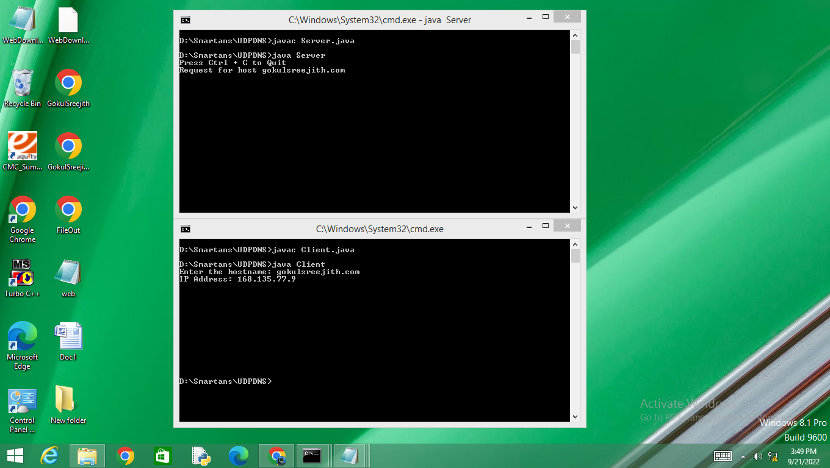

Server :

import java.io.\*;

import java.net.\*;

public class Server{

private static int indexOf(String[] array, String str){

str = str.trim();

for (int i = 0; i < array.length; i++){

if (array[i].equals(str))

return i;

}

return -1;

}

public static void main(String arg[]) throws IOException {

String[] hosts = { "yahoo.com", "gmail.com", "cricinfo.com", facebook.com","gokulsreejith.com"};

String[] ip = {"68.180.206.184", "209.85.148.19", "80.168.92.140", "69.63.189.16","168.135.77.9"};

System.out.println("Press Ctrl + C to Quit");

while (true){

DatagramSocket serversocket = new DatagramSocket(1362);

byte[] senddata = new byte[1021];

byte[] receivedata = new byte[1021];

DatagramPacket recvpack = new DatagramPacket(receivedata, receivedata.length);

serversocket.receive(recvpack);

String sen = new String(recvpack.getData());

InetAddress ipaddress = recvpack.getAddress();

int port = recvpack.getPort();

String capsent;

System.out.print("Request for host " + sen);

if (indexOf(hosts, sen) != -1)

capsent = ip[indexOf(hosts, sen)];

else

capsent = "Host Not Found";

senddata = capsent.getBytes();

DatagramPacket pack = new DatagramPacket(senddata, senddata.length, ipaddress,port);

serversocket.send(pack);

serversocket.close();

}

}

}

Client :

import java.io.\*;

import java.net.\*;

public class Client{

public static void main(String args[])throws IOException {

BufferedReader br = new BufferedReader(new InputStreamReader(System.in));

DatagramSocket clientsocket = new DatagramSocket();

InetAddress ipaddress;

if (args.length == 0)

ipaddress = InetAddress.getLocalHost();

else

ipaddress = InetAddress.getByName(args[0]);

byte[] senddata = new byte[1024];

byte[] receivedata = new byte[1024];

int portaddr = 1362;

System.out.print("Enter the hostname: ");

String sentence = br.readLine();

senddata = sentence.getBytes();

DatagramPacket pack = new DatagramPacket(senddata, senddata.length, ipaddress, portaddr);

clientsocket.send(pack);

DatagramPacket recvpack = new DatagramPacket(receivedata,receivedata.length);

clientsocket.receive(recvpack);

String modified = new String(recvpack.getData());

System.out.println("IP Address: " + modified);

clientsocket.close();

}

}